A regional watchdog view 11th October 2018

By Andrew von Dadelszen
Current BOP Regional Councillor

Please note that views expressed in my column are my personal views and do not necessarily reflect Regional Council policy.

Light rail on tracks is so yesterday. Welcome to the brave new world of driverless vehicles
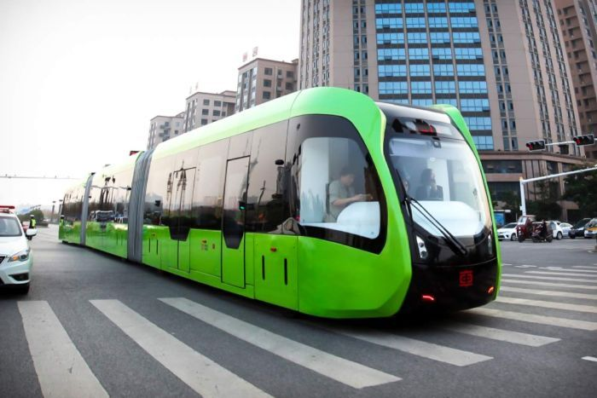
Trackless trams which run on virtual rail lines have been tested in China. Singapore and the United Kingdom Governments are very much on the front foot trying to plan for this. Political, legislative, regulatory and economic issues are going to be much more important than the technological issues.
Autonomous trackless trams will be operating commercially around the globe within the next year or so. Heavy rail will only make sense for heavy haulage, and even then, maybe not for that much longer. Building roads is infinitely cheaper than building (or replacing) rail lines. Driverless trucks and cars just require the ethical issues to be resolved. Autonomous vehicles are almost here as the norm – rather than just being trialled.
This will change the way we think about public transport (and private transport too). Tauranga has the opportunity to be a world leader in this. We need to rethink our Transport Blueprint to ensure that we capitalise on these exciting technologies.

If you have a view on these or any other local government issues, I invite you to email me at andrew@vond.co.nz , or visit www.vond.co.nz

